Faculty of Computers and Artificial Intelligence Information Systems Department

Artificial intelligence

Fall semester 2023-2024

Artificial intelligence

***Team Members***

|  |  |  |  |
| --- | --- | --- | --- |
|  | **Name** | **ID** | **Total grade(35)** |
| **1** | عبدالله فبصل رجب جمعه | 20210553 |  |
| **2** | عبدالله وائل السيد | 20210563 |  |
| **3** | عبدالله محمد حلمي | 20210555 |  |
| **4** | الحسين علي عبدالباسط | 20210177 |  |
| **5** | حسام الدين محمد عبدالفتاح مطر | 20210283 |  |
| **6** | يوسف علي أنور عطاالله | 20211084 |  |

**Graph Colouring Problem Solver using the Backtracking Search Algorithm, AND a**

**Genetic Algorithm.**

**- Project idea and overview**

.. The Graph Coloring Problem is a well-known combinatorial optimization challenge that involves

assigning colors to the vertices of a graph in such a way that no two adjacent vertices share the same color. This

project aims to develop an intelligent Graph Coloring Problem Solver utilizing both the Backtracking Search

Algorithm and a Genetic Algorithm.

Problem Description: In the Graph Coloring Problem, we have a graph composed of vertices and edges. The

objective is to color each vertex in a way that no two connected vertices have the same color. The minimum

number of colors required to achieve this is known as the chromatic number of the graph. Our task is to find a

valid coloring solution that minimizes the chromatic number.

**-The Main functionalities**

1- input graph

2- choose the algorithm

3-solve with backtracking

4-solve it with genetics

5-input genetic algo parameter

6-use minimum number of colors

7-color the graph

8-plot the graph

**-Use case**

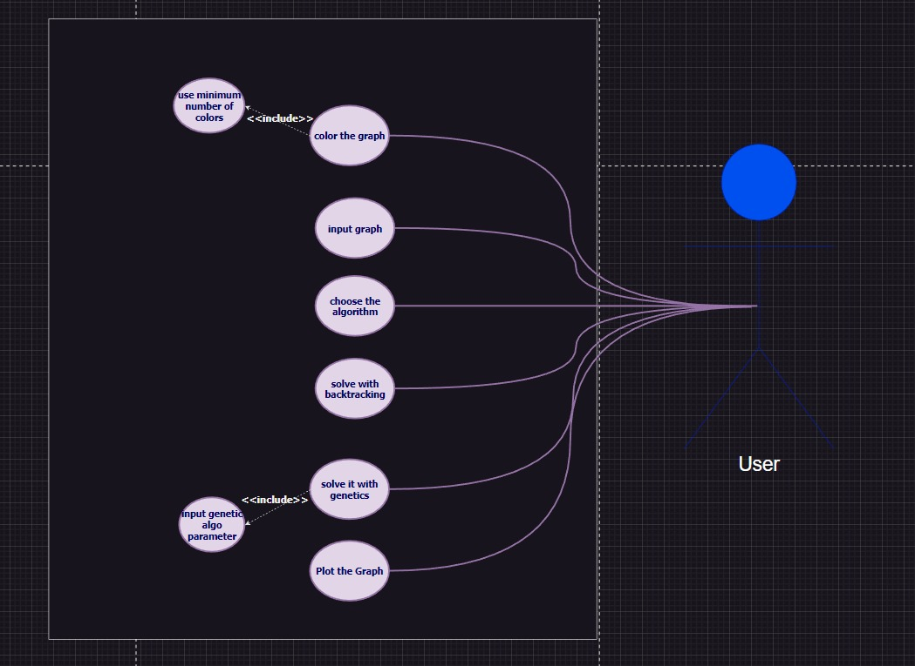

**-Flowchart diagram**

**Network Block Diagram:**

**Experiment & result:  
  
**

Number of nodes: 5  
edges:  
1 3

1 2

2 5

2 3

3 4

Backtracking time and chromatic number :

Genetics time and chromatic number:  
population size = 20  
no of generations = 10  
Mutation rate = 0.1  
crossover probability = 0.6  
retain = 0.2

So based on the results backtracking algorithm is faster than genetic algorithm and both of them give the optimal solution.

**Genetic Algorithms:**

**Advantages**:

1. Global Optimization:
   * GAs are effective in finding global solutions in large solution spaces.
2. Adaptability:
   * Suitable for a wide range of optimization problems and adaptable to complex scenarios.
3. Parallelism:
   * Parallelizable, enabling efficient processing in parallel computing environments.

**Disadvantages**:

1. Parameter Sensitivity:
   * Performance can be sensitive to parameter settings, requiring careful tuning.
2. Computational Complexity:
   * Can be computationally expensive, particularly for large-scale problems.

**Backtracking Algorithm:**

**Advantages**:

1. Deterministic Solution:
   * Provides a deterministic solution and guarantees finding an optimal solution.
2. Simplicity:
   * Simpler to understand and implement, suitable for smaller problems.

**Disadvantages**:

1. Limited Scalability:
   * Faces challenges with scalability, especially for very large problems.
2. Exponential Complexity:
   * Worst-case time complexity is exponential, leading to longer execution times for certain instances.

**Genetic Algorithm (GA):**

Behavior Analysis:

1. **Parameter Tuning:**
   * Evaluate the impact of parameter settings on GA performance.
2. **Convergence Analysis:**
   * Analyze convergence behavior for adjustment if needed.
3. **Diversity Maintenance:**
   * Ensure the GA maintains sufficient population diversity.

**Future Modifications:**

1. **Adaptive Parameter Tuning:**
   * Implement adaptive parameter tuning during execution.
2. **Enhanced Operators:**
   * Experiment with improved crossover and mutation operators.
3. **Niching Strategies:**
   * Introduce niching strategies for diverse subpopulations.
4. **Hybrid Approaches:**
   * Explore hybrid approaches with other optimization techniques.

**Backtracking Algorithm:**

Behavior Analysis:

1. **Graph Structure:**
   * Analyze behavior in relation to different graph structures.
2. **Complexity Analysis:**
   * Assess time and space complexity for optimization points.

Future Modifications:

1. **Optimizations for Specific Cases:**
   * Identify and optimize scenarios where backtracking struggles.
2. **Dynamic Ordering:**
   * Experiment with dynamic node ordering strategies.
3. **Parallelization:**
   * Explore parallelization techniques for distributed exploration.
4. **Memory Reduction Techniques:**
   * Implement strategies to reduce space complexity.
5. **Hybrid Approaches:**
   * Investigate hybrid approaches, combining backtracking with other techniques.